Nepal College of Information Technology
Assessment
Spring 2010
Program : BE ELX/CE Time : 3 hrs
Semester : Spring (II) FM : 100
Subject : Electronic circuits PM : 50

- Candidates are requested to give their answer as far as practicable in their own words.
- The figure in the margin indicates the full marks
- Attempt ALL question
1. a) Common Collector is also called as emitter follower, why? Obtain its small signal analysis with necessary expressions. 2+5
b) Find overall gain in the circuit below: (β=100, r_{e} = 50 Ω, r_{c} = 1MΩ) 8
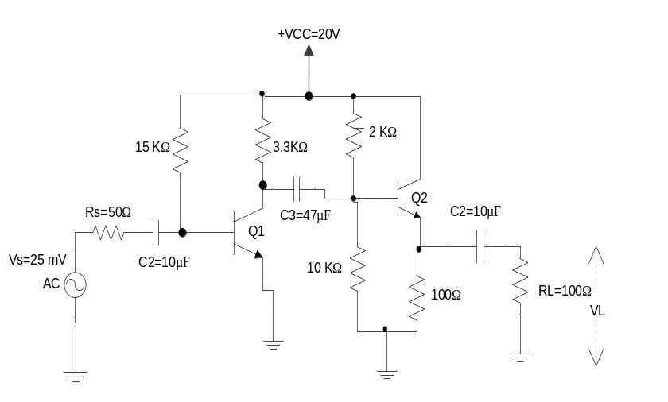
2. a) What do you mean by Distortion? Explain its types. 7
b) What do you mean by inter electrode and miller capacitance? Describe the effect of bypass capacitor on low frequency response. 3+5
3. a) What do you mean by push pull amplifiers? Derive the efficiency of a class B amplifier. 2+5
b) Draw class-AB amplifier and Explain, how does it help to remove crossover distortion. 8
4. a) What are the advantages of negative feedback? An amplifier has an open loop gain of 500 and a feedback ratio of 0.04. If the open loop gain changes by 25% find the percentage change in closed loop gain. 2+5
b) Differentiate between regulated and unregulated power supplies. “Shunt regulator helps to maintain a constant output voltage”, Explain. 3+5
5. a) Show that the differential gain of an Instrumentation Amplifier is (1+2R/R_{A}). 8
b) Design an Operational Amplifier circuit that produces an output equal to – (5v1+3v2+0.8v3) 7
6. a) Calculate the output voltage from the circuit below. 5
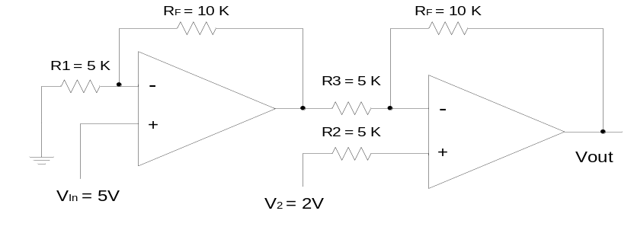
b) What do you mean by a log amplifier? “A practical log amplifier helps to make output voltage independent of the saturation current”. Show with necessary figure and mathematical derivations. 8
7. a) Describe the operation of successive approximation A/D. 5
b) What do you mean by resolution? Design a 4 bit, weighted resistor D/A, whose full scale output voltage is - 10V. Logic levels are 1= +5V and 0=0V. What is the output voltage when the input is 1001? 7

